**ARTICLE TITLE**

**(TIMES NEW ROMAN, 16, BOLD, CENTER, SINGLE SPACING, UPPERCASE)**

**Author Name1 (superscript)**

**Author Name2 (superscript)**

**(Times New Roman, 12, Bold, Center, Single Spacing, Capitalize Each Word)**

(superscript) 1,2Institution

*Corresponding author. Email: [author@example.com](mailto:author@example.com)

(Times New Roman, 10, Center, Capitalize Each Word)

__________________________________________________________________________________________

***Abstract:*** (*Times New Roman, 12, italic, justify, single spacing) - The abstract should* ***not more than 200 words each****. The abstract should not only indicate the subject and scope of the manuscript, but also summarize the author’s conclusion. Structured abstract must be a brief, comprehensive summary of the contents of the manuscript. It allows readers to survey the contents of an article quickly. An Abstract summarizes the major aspects of a paper. It should succinctly summarize the purpose of the manuscript, the methods used, the major results, and conclusions.*

***Keywords:*** *(Times New Roman, 12, Italic, Justify, Single Spacing, Capitalize Each Word) - Min 3 Keywords and Max 5 Keywords)*

***___________________________________________________________________________***

**Introduction – Heading 1 (Times New Roman, 12, Bold, Align Left, Capitalize Each Word)**

The introduction should present a problem/concept/previous research clearly and concisely as the basis for conducting the research that will be written as a scientific article. The introduction must also explain why the research topic was chosen and considered important, and it should end with a statement of the research objectives. Only literature that is truly important and relevant to the issue should be cited to “justify” the research or to form the basis of the hypothesis. Literature cited throughout the manuscript should preferably come from articles in scientific journals. References to articles in this journal are a maximum of the last 10 years from primary sources to strengthen justification of the originality or contribution of this research title. Before writing the purpose of the study, there must be a Gap Analysis or a gap statement (originality) or a novelty contribution statement clearly and explicitly, or what is the difference / uniqueness of this research compared to previous studies, also in terms of the importance of this research being carried out after that, then write the research objectives in this article straightforwardly and clearly.

(Times New Roman, 12, single spacing, justify)

**Method – Heading 2 (Times New Roman, 12, Bold, Italic, Tab Inside, Capitalize Each Word)**

The methods section contains the type of research, time and place of research, targets, research subjects, procedures, data and instruments, and data collection techniques, as well as data analysis techniques and other matters relating to the method of research can be written without sub- subchapters. The content of the paragraph writing in the method is adjusted to the type of research. (Times New Roman, 12, single spacing, justify)

**Result and Discussion– Heading 3 (Times New Roman, 12, Bold, Italic, Tab Inside, Capitalize Each Word)**

The research results presented should only include meaningful findings that are relevant to the research objectives (Siram, 2013). The results section contains research findings obtained from the research data and related to the hypothesis (Sugiyono, 2011). In the discussion section, the relationship between the research findings and theories or previously published research results in various scientific journals (preferably from the last 5–10 years) is explained.

Research results are presented in graphical, tabular, or descriptive form. Analysis and interpretation of these results is required before they are discussed. The data presented is not raw data but data that has been analyzed. The presentation of research results in tables and figures needs to be given an explanation/review but not discuss it in detail.

Tables and figures/graphs must be understandable and provided with sufficient captions (font size 11). Ensure that all images in your article: (1) have adequate color contrast, (2) are clear enough, and (3) have legible labels. The format for presenting tables and figures is shown in Table 1, as well as Figures 1 and 2.

(Times New Roman, 12, single spacing, justify)

**Table 1: Example**

**(Times New Roman, 12, Single Spacing, Bold, Center, Capitalize Each Word)**

|  |  |  |
| --- | --- | --- |
| **Example** | **Example** | **Example** |
| Example | Example | Example |
| Example | Example | Example |

Source: (Times New Roman,10, Single Spacing, Align Left, Capitalize Each Word)

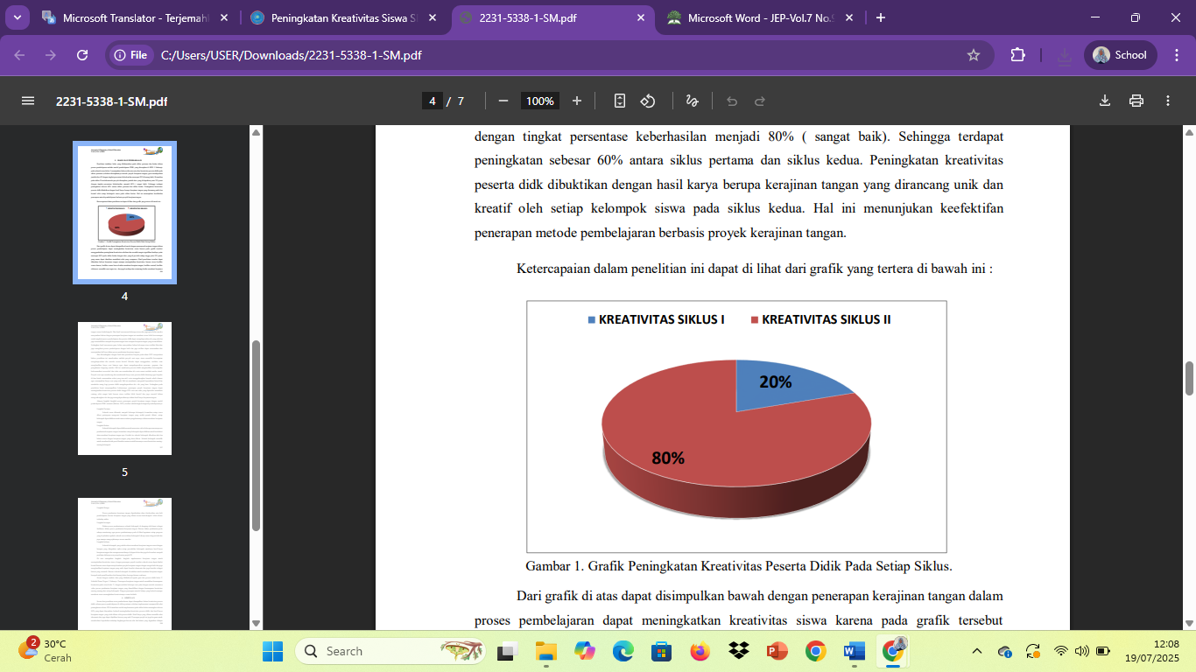

**Figure 1: Example**

**(Times New Roman, 12, Single Spacing, Bold, Centre, Capitalize Each Word)**

Source: (Times New Roman,10, Single Spacing, Align Left, Capitalize Each Word)

**Conclusion – Heading 3 (Times New Roman, 12, Bold, Italic, Tab Inside, Capitalize Each Word)**

The conclusion is not merely a repetition of data, but rather a substantive interpretation. This section provides answers to the hypothesis, research objectives, and findings, as well as suggestions related to further ideas stemming from the research. Conclusions are written in paragraph form, not in item list/numbering form.

(Times New Roman, 12, single spacing, justify)

**References (APA Sixth Edition, Single Spacing)**

Written in single space, between the bibliography is spaced 1 space. The number of reference sources used as a bibliography of scientific literature is at least 15 references with acomposition of 70% from primary references such as: journals, research reports, and proceedings papers and 30% secondary references such as: books, theses, theses, dissertations, and internet sources. Referenced journal references come from international journals and accredited national journals.

Alsubaie, M. A. (2016). Curriculum Development: Teacher Involvement in Curriculum Development. *Journal of Education and Practice*, *7*(9), 106-107.

***(Minimum references 15 (70% from published work)***

**Notes:**

* Example for numbering figure are: Figure 1, Figure 2, Figure 3 ….so on.

* Example for numbering table are: Table 1, Table 2, Table 3 …….so on.

* Please refer above example for table and figure.

* Minimum reference 15 (70% from published work)

* Paper lengths range from 15-20 pages

* A4 paper; all margins 2.5cm